Elastic search

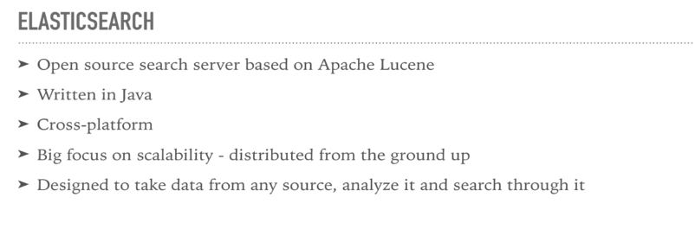 [ElasticSearch](http://www.elastic.co) is an Open-source Enterprise REST based Real-time Search and Analytics Engine. It’s core Search Functionality is built using Apache Lucene, but supports many other features.

It is written in Java Language. It supports Store, Index, Search and Analyze Data in Real-time. Like MongoDB, ElasticSearch is also a Document-based NoSQL Data Store.

**ElasticSearch Features:-**

* An Open-source
* Supports Full-text Simple and Powerful Search
* Supports REST Based API (JSON over HTTP)
* Supports Real-time Search and Analytics
* By Definition, Distributed
* Supports Multi Tenancy Feature
* Support Cloud and Big Data Environments
* Supports Cross-platform
* Denormalized NoSQL Data Store

**Advantages or Benefits of ElasticSearch:-**

* An Open-source
* Light Weight with REST API
* Highly Available. Easily and Highly Scalable
* Supports Caching Data
* Schema Free
* Fast Search Performance
* Supports both Structured and UN-Structured Data
* Supports Distributed, Sharding, Replication, Clustering and Multi-Node Architecture
* Supports Bulk Operations
* Build Charts and Dashboards within no time

**Drawbacks or Limitations of ElasticSearch:-**

* Does NOT support MapReduce operations
* Not useful as a Primary Data Store
* Not an ACID compliant Data Store
* Does not support Transactions and Distributed Transactions
* Does NOT have built-in authentication or authorization feature

**Popular Clients who are using ElasticSearch:-**

* Github.com, Quora.com, Stackoverflow.com
* eBay, DELL, Cisco, Mozilla, Wikimedia
* Netflix, Symatics, Facebook
* UK HMRC (HM Revenue & Customs)

**2. ElasticSearch REST API URL Basics:**

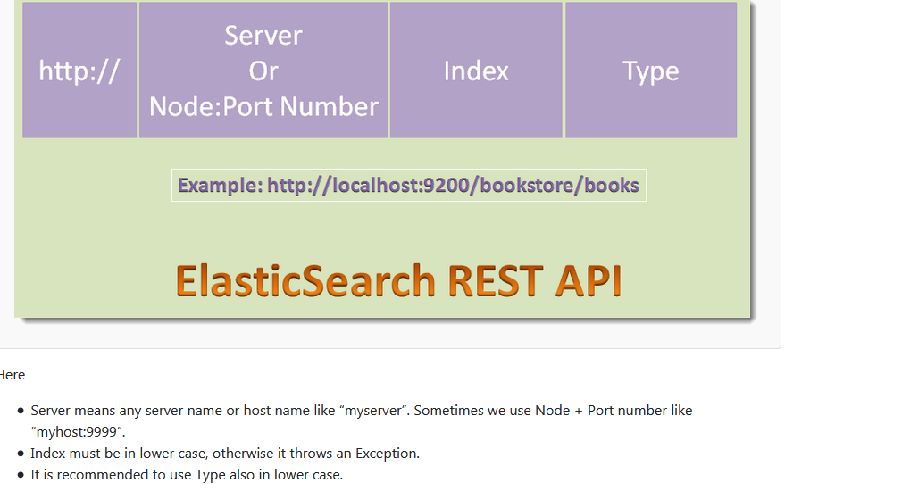

## 3. ElasticSearch Terminology

We will discuss few important ElasticSearch Terminology: Index, Type, Document, Key, Value etc.

**3.1 What is an Index in ElasticSearch?**  
In ElasticSearch, an Index is a collection of Documents. For instance, “bookstore” is a Document. Index is used for indexing, searching, updating and deleting Documents. It must be in lower case.

An Index is similar to Database in Relation Database World.

**3.2 What is a Type in ElasticSearch?**  
In ElasticSearch, a Type is a category of similar Documents. That means we can group a set of similar Documents into a Type. As we know in real-world, a “bookstore” contains different kinds of items: a collection of “Books”, a collections Pens, Pencils, CDs etc. In the same way, “bookstore” Document (One kind of Index) can contain a collection of Types: books, pens,CDs etc.

A Type is similar to Table in Relation Database World.

**3.3 What is a Document in ElasticSearch?**  
In ElasticSearch, a Document is an instance of a Type. It contains Data with Key and Value fairs. For instance, “title”:”Functional Programming In Java” is a Key:Value fair of a Document of Type:”Books”. Each Document has an id.

A Document is similar to a Row in a Table in Relation Database World. Key is Column name and value is Column value.

